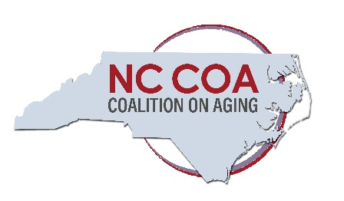
PIONEER AWARD
CALL FOR NOMINATIONS—2022

The North Carolina Coalition on Aging established the Pioneer Award to recognize individuals who have made long-time outstanding contributions to the field of aging in North Carolina. The Award not only honors recipients for their meritorious service, but a secondary purpose is to help enhance visibility of the field of aging and the work that has been done and is still on-going to address the needs of older North Carolinians.

Selection Criteria
• Nominee has enhanced the lives of older North Carolinians through long-time demonstrated contributions (fifteen years or greater) to aging-related administration, service delivery, advocacy, public policy, or research in North Carolina.
• Individuals cannot be self-nominated.
• The nominator must be an active member of the NC Coalition on Aging.

To Submit a Nomination
Written nominations MUST include:
• Completed Award Nomination Application
• Maximum of a two-page written narrative which includes a bulleted description of why the nominee should be recognized.
• One letter of support for the nominee written by someone other than the nominator (State relationship to nominee and reasons for support.)
The deadline for submission of nominations is September 1, 2022. Completed applications should be e-mailed to Heather Burkhardt at executivedirector@nccoalitiononaging.org.

Please note that that Award recipients will be recognized at the annual meeting and luncheon of the NC Coalition on Aging which will be held on Friday, September 23, 2022, in Coalition news alerts, and on the Coalition’s website and social media. Winners will be asked to submit a color photograph which can be used for publicity purposes.

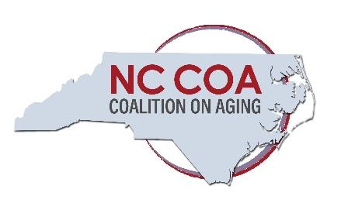
PIONEER AWARD
NOMINATION APPLICATION
On a separate page include a written narrative which includes a bulleted description of why the nominee should be recognized for long-time outstanding contributions to the field of aging in North Carolina. Include service in the NC Coalition on Aging or in other leadership roles.
Nominations must include a letter of support for the nominee written by someone other than the nominator. Please state the relationship to nominee and reasons for support. The deadline for submission of nominations is September 1, 2021.
Contact Information for the Nominator:
Name _________________________________________ Job Title___________________________
Organization ___________________________________
Address____________________________________________________________________________
City/State/Zip ______________________________________________________________________
Phone __________________________________ Email _____________________________________
Is the nominator a member of the Coalition on Aging? Yes__ No__

Contact Information for the Nominee:
Name _________________________________________ Job Title ___________________________
Organization_______________________________________________________________________
Address____________________________________________________________________________
City/State/Zip______________________________________________________________________
Phone __________________________________ Email ____________________________________
Length of affiliation with or employment in the aging field____________________________

Completed applications should be e-mailed to Heather Burkhardt at executivedirector@nccoalitiononaging.org

