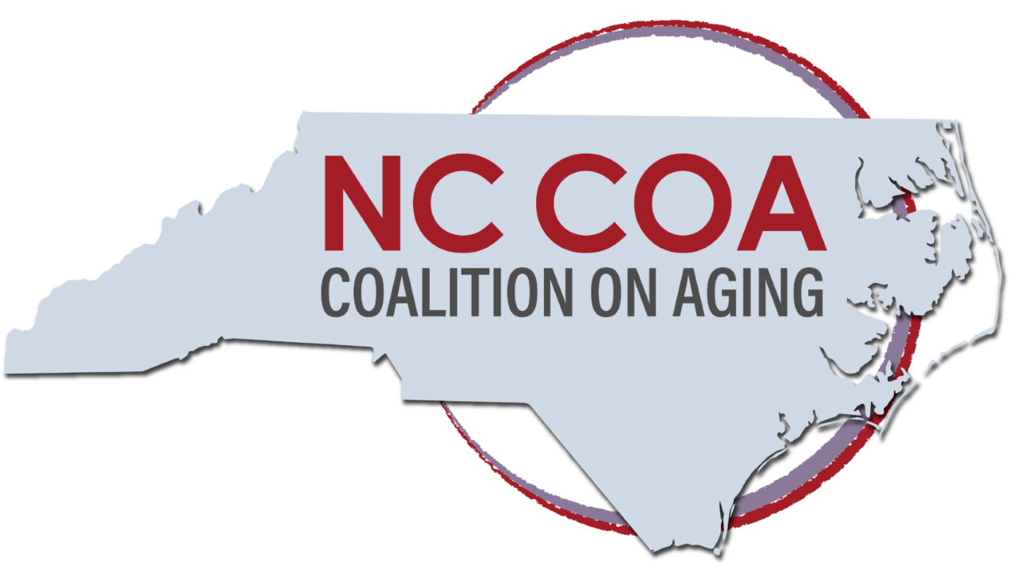
NCCOA Membership Meeting
Friday, Feb. 25, 2022
10:00 am - 12:00 pm on Zoom
Attendees:
Alan Winstead, Meals on Wheels of Wake County
Allyse Buck, Meals on Wheels of Wake County
Althea Taylor Jones, NC Senior Tar Heel Legislature/SGS
Ana Pardo, NC Justice Center
Autumn Cox, Triangle J Council of Governments Area Agency on Aging
Betsy White, Access Dental Care
Bob Cleveland, Piedmont Triad Regional Council Area Agency on Aging
Brooke Baragona, SembraCare
Chanelle C.C. Croxton , National Domestic Workers Alliance
Carolyn Pennington, Triangle J Council of Governments Area Agency on Aging
Catherine Sevier, NC Serious Illness Coalition
Crystal Adams, NC Oral Health Collaborative
Dale Neal, Alignment Healthcare
Daunita Maennle, Cherokee County DSS/Individual Member
David Litman, RHA
Deryl Davis Fulmer, NC Governmental Employees' Association
Dick Chady, NC Continuing Care Residents Association/NC Third Age
Ed Rosenberg, NC Governor's Advisory Council on Aging
Ellen Bailey, NC Center for Health and Wellness/UNC-Asheville
Guy Brown, NC Alliance for Retired Americans
Harold Barnette, Institute for Family Caregiving
Heather Burkhardt. NC Coalition on Aging
Holly Pilson, Cape Fear Council of Governments Area Agency on Aging
James How, FCC
Janice Tyler, NC Association on Aging/Orange County Department on Aging
Jeff Horton, NC Senior Living Association
Jillian Hardin, Brunswick Senior Resources
Joyce Massey Smith, NC DHHS, Division of Aging and Adult Services
Jo Paul, NC Department of Insurance/SHIIP
Karen Brewer, NC Assisted Living Association
Katie Franklin, NCDHHS/Division for Services for Deaf and Hard of Hearing
Kay Castillo, National Association of Social Workers-NC Chapter
Kezia Scales, PHI
Lee Dobson, Bayada
Lisa Riegal, AARP-NC
Lacee Monte, Chatham County Council on Aging
Lora Felger, FirstCareolinaCare
Madeline Rickett, NC Coalition on Aging, Intern
Roger Manus, NC Governor's Advisory Council on Aging
Marisette Hasan, The Carolinas Center
Mark Hensley, AARP-NC
Martha Fowler, SEANC
Marty Lamb, FOR/Individual Member
Mary Bethel, NC Coalition on Aging, Board Chair
Mary Lucas, Transitions Life Care
Mary Marlin, Upper Coastal Plain Council of Governments Area Agency on Aging
Mary Warren, Triangle J Council of Governments Area Agency on Aging
Mary Williams-Stover, NC DHHS
Nancy Ruffner, Navigate NC
Natasha Vos, NC Center for Health and Wellness/UNC-Asheville
Patricia Calloway, Generations Ashe
Rebecca Freeman, NC DHHS, Division of Aging and Adult Services
Romona McGinnis, Captionist
Rosalie Calarco, AARP-NC
Susan Butler-Greene, Seniorlink
Sue Gregg
Susan Bone, Triangle J Council of Governments Area Agency on Aging
Suzanne LaFollette-Black, AARP-NC Volunteer
Thomas Konrad, FOR Volunteer
Tom Akins, LeadingAgeNC
Tracy Colvard, Maxim Healthcare
Zoe Taylor

Opening Remarks: Mary Bethel, Chair of the Board, opened the meeting at 10:01 a.m.
Dave Richard, NC DHHS Deputy Secretary for Medicaid, gave a briefing on how the state is leveraging federal aid to improve salaries for direct care workers in home and community-based services, as well as in nursing homes.
- The American Rescue Act lets us save $300 million in state funds to cover a total of $900 million; DHHS is presenting a plan to CMS to give priority to increasing wages to direct care workers.
- Although the federal aid is non-recurring, the NCGA created the Home and Community Based Services Fund as a permanent part of the state budget, funded by a tax on hospitals.
- Our goal is to move toward $15/hour for Personal Care Services workers. DHHS will encourage, but not require, providers to spend 80 percent of these funds on wages. They will monitor the results.
- Although nursing homes received higher Medicaid rates during COVID, they cannot take advantage of the HCBS funds now. DHHS is working with the NCGA to find other ways.

Finance: Treasurer Dick Chady reported a checking account balance of 107,520.82
As of Feb. 24, 2022. The report was accepted.
Minutes from the Jan. 28, 2021 meeting were unanimously approved with no changes.
- Heather Burkhardt, Executive Director, reported:
- The Z. Smith Reynolds Foundation awarded NCCOA $60,000 over two years to advocate for statewide systemic change for direct care workers. To leverage this funding, we are exploring additional grant possibilities with (a) the Duke-UNC “Money Follows the Person” project for those transitioning from nursing homes back to the community and (b) with the Serious Illness Coalition on “Changing the Care Conversation.”
- As part of our Essential Jobs, Essential Care initiative with PHI, NCCOA will participate in three, 90-minute webinars with collaborating states MI and NM on March 8, 15 and 22. On March 30, NCCOA will host one for NC only.(See other newsletters for details on how to register.)
- Two recent initiatives have been very successful: Spotlight on Members on social media every Monday and the first New Member Mingle on Zoom.
- Members Harold and Willetha Barnette participated in a Kaiser Family Foundation webinar on how different seniors showed resilience during the pandemic.

- During the Joint Legislative Oversight Committee on Medicaid and NC Health Choice, Sandy Terrell, Chief Clinical Officer of NC Medicaid, DHHS estimated that 81,000 direct care workers will get bonuses under the new federal and state funds.
- Deryl Davis Fulmer, NCRGEA, co-chair of Health Equity Workgroup, reported they had about 50 people for Zoom training for LGBTQ+ inclusivity; On March 11, the workgroup will host its first meeting with a presentation on “Advancing Health Equity for Older Adults.” Guest speakers re Sahar Takshi, staff attorney at Justice in Aging; Cornell Wright, Executive Director of the NC DHHS Office of Minority Health and Health Disparities.

- Intern Madeline Rickett reported very positive results for the Membership Survey. There was high praise for Heather and Mary; some members sought improvement on social media and better orientation. Madeline will do a fact sheet.

Sharing by Coalition Members
- Tom Akins, Leading Age of NC, said they have engaged a consultant for Diversity, Equity and Inclusion (DEI) initiatives for their 46 nonprofit CCRCs and 17 affordable housing providers. They will share he results with NCCOA.
- Jillian Hardin of Carolina Active Living Centers, said they are promoting the concept of active older adults.
- Ellen Bailey, NC Center for Health and Wellness, said they seek DEI coordination with other groups.
- Kay Castillo, NASW, said they planned several virtual events for March as Social Work Month.

Rebecca Freeman, NC DHHS Division of Aging and Adult Services. said the Healthy Aging Task Force meets April; 2. They are working with NCCOA, NC Senior Games and others to present older American events on “Age My Way” theme. Also, the Senior Tar Heel Legislature has new leadership; the next virtual meeting is March 15.
- Betsy White said Access Dental Care will take a mobile van to senior centers in New Hanover County and seek other partners to provide dental services for 55+, low-income and uninsured people.
- Board Chair Mary Bethel: Reminded people that the Joint Legislative Oversight Committee On Medicaid And NC Health Choice is considering Medicaid expansion. We must plan for the legislative short session starting in May.

Meeting adjourned 11:45 a.m.

Respectfully submitted
Dick Chady
Secretary/Treasurer
March 7, 2022

Upcoming Events
Advocacy Skills Training
- Tuesday, March 8, 2022 from 12- 1:30 pm: Convening and Mobilizing a Strong Coalition
- Tuesday, March 15, 2022 from 12- 1:30 pm: Communicating the Value of Care Work
- Tuesday, March 22, 2022 from 12- 1:30 pm: Building the Relationships you Need to Win

- Friday, March 25, 2022 from 10:00 am -12:00 pm: Membership Meeting
- Wednesday, March 30, 2022 from 9 am – 12:00 pm: NC’s 2nd Annual Direct Care Workforce Convening

Schedule of NCCOA Executive Committee, board and members meetings for 2022

Full Board Meetings: 2nd Mondays of the quarter 10 a.m.- 12 p.m.
March 14, 2022
June 13, 2022
September 26, 2022
December 12, 2022

Executive Committee meetings: 2nd Tuesdays of the month from 10 a.m. - 12 p.m. (may not be full meeting if not needed)
April 12
May 10
July 12
August 9
October 11
November 8

Membership Meetings: Typically, the 4th Friday of the month 10 a.m.- 12 p.m.
March 25, 2022
April 22, 2022
May 20, 2022
June 24, 2022
August 26, 2022
September 23* Annual Meeting
October 28, 2022
December 2, 2022

