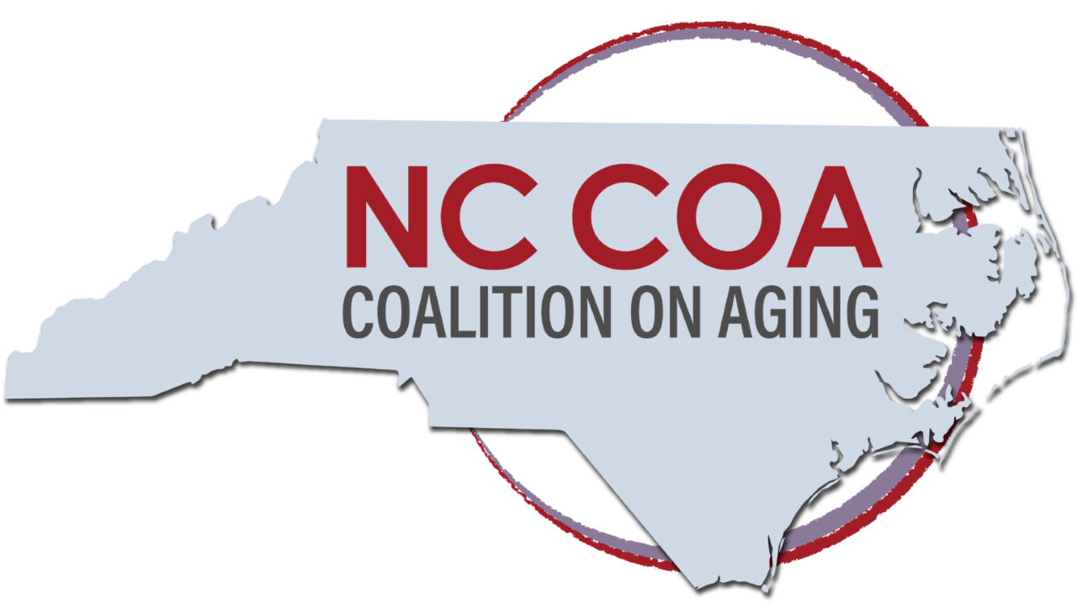
NCCOA Membership Meeting
Friday, Jan. 28, 2022
10:00 am - 12:00 pm on Zoom
Attendees:
Alan Winstead | Meals on Wheels of Wake County
Allyse Buck | NC State University
Angela Bryant | NC Department of Health and Human Services
Angela Ellis | Martin County Department of Social Services
Audrey Edmisten | NC DHHS, Division of Aging and Adult Services
Barbara Berney | BLB Film Productions
Bill Lamb | Friends of Residents in Long Term Care (FOR)
Christy Walker | Captionist
Chanell McCain | IPRO/Individual member
Crystal Adams | NC Oral Health Collaborative
Dale Neal | Alignment Healthcare
Daunita Maennle | Cherokee County DSS/Individual Member
Demarcus Andrews | The Center for Responsible Lending
Deryl Davis Fulmer | NC Governmental Employees' Association
Dick Chady | NC Continuing Care Residents Association/NC Third Age
Edward Jones | Land of Sky Regional Commission
Elaine Whitford | The Center for Volunteer Caregiving
Gail Miller | North Carolina Senior Tar Heel Legislator
Gina Upchurch | Senior PharmAssist
Guy Brown | NC Alliance for Retired Americans
Harold Barnette | Institute for Family Caregiving
Heather Altman | Harmony Advisors/Individual member
Heather Burkhardt | NC Coalition on Aging, Executive Director
Jamie Philyaw | UnitedHealthcare
Janice Tyler | NC Association on Aging/Orange County Department on Aging
Jeff Horton | NC Senior Living Association
Jillian Hardin | Brunswick Senior Resources
Joe Wheeler | SAGE of Central NC
John Gibbons | RHA Health Services
Julia Burrowes | Centralina Area Agency on Aging/Individual member
Karen Appert | Appert Marketing, NC Serious Illness Coalition
Kathie Smith | Association on Home and Hospice Care of NC
Katie Franklin | NCDHHS/Division for Services for Deaf and Hard of Hearing
Kay Castillo | National Association of Social Workers-NC Chapter
Kevin Robertson | NC Department of Insurance/Senior Medicare Patrol
Kezia Scales | PHI
Laurie Dotson | Buncombe County Health and Human Service
Les Geller | SAGE Central NC
Lisa Hoskins | The Center for Volunteer Caregiving
Madeline Rickett | NC Coalition on Aging, Intern
Roger Manus | Governor's Advisory Council on Aging
Marisette Hasan | The Carolinas Center
Mark Hensley | AARP NC
Marty Lamb | FOR/Individual Member
Mary Bethel | NC Coalition on Aging, Board Chair
Mary Lucas | Transitions Life Care
Mary Marlin | Upper Coastal Plain Council of Governments Area Agency on Aging
Mary Williams-Stover | NC DHHS
Michael Dawkins | NC Department of Insurance/SHIIP
Melinda Munden | NC Department of Insurance/SHIIP
Nancy Ruffner | Navigate NC
Nancy Warren | NC Partnership to Address Adult Abuse
Natasha Vos | NC Center for Health and Wellness/UNC-Asheville
Nicolle Miller | Partners in Health
Paola Learoyd | Randolph Cloud Associates
Pat Martin | Community & Senior Services of Johnston County
Preston Craddock | Greene County Department of Social Services
Rosalie Calarco | AARP NC
Sandy Deutsch | Wake County Community Advisory Committee
Susan Bone | Triangle J Council of Governments Area Agency on Aging
Thomas Goldsmith | NC Health News
Tracy Colvard | Maxium Healthcare
Willetha Barnette | Institute for Family Caregiving
Zoe Taylor

Opening Remarks: Mary Bethel, Chair of the Board, opened the meeting at 10:01 a.m.
Finance: Treasurer Dick Chady reported a checking account balance of $79,263.50
as of Jan. 28, 2022. The report was accepted.
Minutes from the Dec. 3, 2021 meeting were unanimously approved with no changes. (Kay Castillo/Alan Winstead)

Angela Bryant, a former state representative and state senator from eastern North Carolina who’s now the NC DHHS Assistant Secretary of Equity and Inclusion, described her career in “putting equity into practice on the ground.” DHHS has recently created the Office of Health Equity to with a vision that “everyone would have a fair opportunity to live a healthy life.”

Ms. Bryant explained that age was a dimension across which Diversity, Equity and Inclusion (DEI) might blossom. It crosses all of the other dimensions of age, race, gender, etc.

The DHHS strategy is to “advance health equity by reducing disparities in opportunities for historically marginalized populations within DHHS and across the state.”

‘Health equity implies that ideally everyone should have a fair opportunity to attain their full health potential and that no one should be disadvantaged from achieving this potential. To advance health equity, we must address the social and structural drivers of inequities.”

There are four levels of analysis and change: Personal, Interpersonal, Institutional and Cultural.

She recommended six strategies in advancing equity care;
- Recognize and address the root cause of the disparity.
- Use data for precise impact.
- Invest in economic well-being of communities.
- Create inclusive teams and strategies.
- Shift support to historically marginalized populations and organizations.
- Change policies, systems and environments.

Gina Upchurch of Senior PharmAssist added, “I’ve heard t said that we focus on the fish rather than the water they swim in.”

Mark Hensley of AARP NC introduced the documentary, “Power to Heal,” PBS documentary narrated by Danny Glover about the long struggle to integrate hospitals in the US. One of the leaders was George Simpkins, a Greensboro dentist, who began suing hospitals for discrimination against Black patients and staff in the 1960s. Hospitals were finally integrated thanks to the “stick” through the enactment of Medicare and Medicaid in 1965.

Deryl Davis Fulmer of the NC Retired Governmental Employees Assn. (NCRGEA) and co-chair of the Coalition’s Health Equity Workgroup, cited her family’s involvement in the civil rights movement. In continuing that struggle, she said the group will present information to help NCCOA’s various members in the constituencies they serve.

Activities and Updates Since December

Heather Burkhardt, Executive Director, thanked Deryl Davis Fulmer and Laura Schlabach of the NC Attorney General’s office. For co-chairing the Health Equity Workgroup. It will meet every other month for two hours. Upcoming events:
- SAGE of CNC will provide training on “Creating Inclusive Services for LGBTQ+ Older Adults” from 9:00-11:00 a.m. on Tuesday, Feb. 15. All members are invited
- At the equity group’s kickoff meeting March 11, Justice in Aging staff will discuss national issues.
- Cornelius Wright, executive director of Minority Health in NC DHHS, will be a later speaker.
- The Coalition will dedicate a Disparity Moment on a different topic each month.

Intern Madeline Rickett will share analysis Membership Survey report next month.

The coalition will ramp up its Direct Care workforce initiative “Essential Jobs Essential Care” with a three-hour advocacy training in March.

Sharing by Coalition Members

Joe Wheeler said that the SAGE CNC Facebook page will have a new post on a prominent LGBTQ Black person every day in February for Black History Month.

Katie Franklin, the hard-of-hearing coordination for NCDHHS, said they are developing consumer guidelines for buying hearing aids over-the-counter when the FDA finally approves that advance.

Gail Miller, a Senior Tar Heel legislative representative from Alamance County, said they are looking to re-energize the organization.

Mary Bethel said recent coalition emails had information on:
- The public comment period is open for the Centers for Medicare and Medicaid Services (CMS) plan to limit coverage for Aduhelm, the controversial Alzheimer’s treatment, to persons in clinical trials.
- The FCC has a new program to pay for Internet access for low-income families.

Mary adjourned the meeting at 12:02 a.m.

Upcoming Events

- New Member Mingle online- Wednesday, February 9 from 4:00 pm – 5:00 pm
- Creating Inclusive Services for LGBTQ+ Older Adults- Tuesday, February 15 from 9:00 a.m. – 11:00 p.m.
- Next Membership Meeting: 10 a.m.-noon Friday, February 25.
- Health Equity Workgroup Friday, March 11, 9:00-11:00 a.m.

Respectfully submitted
Dick Chady
Dick Chady
Secretary/Treasurer
Feb. 1, 2022

Schedule of NCCOA Executive Committee, board and members meetings for 2022

Full Board Meetings: 2nd Mondays of the quarter 10 a.m.- 12 p.m.
March 14, 2022
June 13, 2022
September 26, 2022
December 12, 2022

Executive Committee meetings: 2nd Tuesdays of the month from 10 a.m. - 12 p.m. (may not be full meeting if not needed)
February 8
April 12
May 10
July 12
August 9
October 11
November 8

Membership Meetings: Typically, the 4th Friday of the month 10 a.m.- 12 p.m.
February 25, 2022
March 25, 2022
April 22, 2022
May 20, 2022
June 24, 2022
August 26, 2022
September 23* Annual Meeting
October 28, 2022
December 2, 2022

