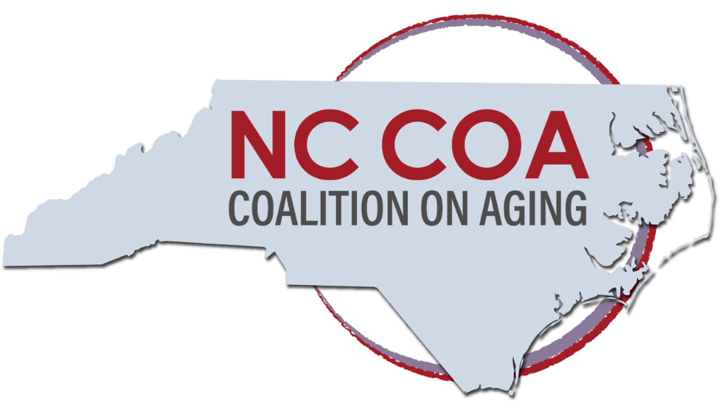
NCCOA Membership Meeting
Friday, October 22, 2021
10:00 am - 12:00 pm on Zoom
Attendees:
Aimee Kepler | Triangle J Area Agency on Aging
Alan Winstead | Meals on Wheels NC
Althea Taylor Jones | NC Senior Tarheel
Ana Pardo | NC Justice Center
Annetta Brown | Upper Coastal Plains Area Agency on Aging
Emily Jones | ASL Interpreter
Jill Dixon | ASL Interpreter
Autumn Cox | Triangle J Area Agency on Aging
Ben Popkin | Popkin Strategies
Bill Lamb | Friends of Residents in Long-term Care
Catherine Sevier | NC Serious Illness Coalition
Chad Walker | Alignment Health Care
Chanell McCain | Individual Member
Daunita Maennle | Cherokee County DSS/Individual Member
Dave Litman | NC Division of Services for the Deaf and Hard of Hearing
David Sevier | NC Serious Illness Coalition
David Rhew | NC Public Transportation Association
Deryl Davis Fulmer | NC Retired Governmental Employees Assocation
Dick Chady | NC Continuing Care Residents Association/NC Third Age
Doug Kim Bai | Individual Member
Frances Messer | NC Assisted Living Association
Hae-Young Yoon | National Domestic Workers Alliance
Haley Williford | Community and Senior Services of Johnston County
Harold Barnette | Institute for Family Caregiving
Heather Burkhardt | NC Coalition on Aging
Janice Tyler | NC Assoication on Aging/Orange County Department on Aging
Jeff Horton | NC Senior Living Association
Karen Appert | Appert Marketing
Kathie Smith | Association of Home and Hospice Care of NC
Katie Franklin | NC Division of Services for the Deaf and Hard of Hearing
Kezia Scales | PHI
Lauren Zingraff | Friends of Residents in Long-term Care
Leah Proctor | NC 211/United Way of NC
Lee Dobson | Bayada
Les Geller | SAGE of Central Carolina/LGBT Center of Raleigh
Linda Atack | Individual Member
Linda Kearsley | Senior Services
Linda Vitsyn | Individual Member
Lisa Hoskins | The Center for Volunteer Caregiving
Lisa Tyndall | Foundation for Health Leadership
Lisa's iPhone | AARP NC
Madeline Rickett | NC Coalition on Aging/UNC School of Social Work Student
Roger Manus | NC Governor's Advisory Council on Aging
Margalita Hooper-Vinson | Mental Health/Substance Abuse Clinician /Individual Member
Marisette Hasan | The Carolinas Center
Martha Fowler | State Employees Association of NC
Mary Bethel | NC Coalition on Aging, Board Chair
Mary Lucas | Transitions Life Care
Nancy Ruffner | Navigate NC
Natasha Vos | North Carolina Center for Health and Wellness/University of North Carolina Asheville
Nedra Williams
Nicolle Miller | North Carolina Center for Health and Wellness/University of North Carolina Asheville
Preston Craddock | Greene County DSS
Rebecca Freeman | NC Division of Aging and Adult Services
Susan Bone | Triangle J Area Agency on Aging
Tom Akins | LeadingAge NC
Tony Davis | NC Division of Services for the Deaf and Hard of Hearing
Tracy Colvard | Maxium Health Care
Willetha Barnette | Institute for Family Caregiving

Opening Remarks: Mary Bethel, Chair of the Board, opened the meeting at 10:01 a.m. She thanked Heather and everyone who helped to produce the ambitious, hybrid in-person and online annual meeting. Mary also recognized new board members: Dick Chady; Martha Fowler;
Minutes from September were unanimously approved with no changes. (Martha Fowler/Allen Winstead)
Treasurer’s Report: Executive Director Heather Burkhardt reported that we closed out the annual meeting expenses; The checking account balance is $67,918, a high point for the year. We are in the process of securing year-long partners for 2022.
Bylaw updates: The Executive Committee proposed to:
- Insert a commitment to equity in the NCCOA's Purpose.
- Specify that the Board of Directors will have four quarterly meetings per year. The Executive Committee meets monthly.
- Change the officer title from Chair-Elect to Vice Chair.
- Add conflict-of-interest statement.
- Clarify the language re in-person meetings, online or teleconference.
The changes were approved unanimously by voice vote (Tom Akins/ Bill Lamb).
Legislative Update
- Heather reported that Gov. Cooper signed S191, the No Patient Left Behind Act, which specifies when and how visitations are allowed in health care facilities. It was supported by Friends of Residents in Long-Term Care and other groups. Bill Lamb said FORLTC will develop ways to inform families what their visitation rights are.
- She said that indications are we may have a final budget by Halloween.
- David and Catherine Sevier of AARPNC reported no progress on the Advance Care Planning legislation. They are seeking ways to “light a fire” on the bill.
- Tom Akins of Leading Age reported said they are attempting to find out if a tax issue involving CCRCs has survived talks with the two chambers and governors.
Build Back Better Act
Haeyoung Yoon, Senior Policy Director, National Domestic Workers Alliance, said that she was getting “consistent affirmation” that financial aid for expanding Home and Community-Based Services (HCBS) was still included in the draft Build Back Better Act. Although it was originally funded at $190 billion to expand services and raises wages for workers, the funding level remained TBD.
Kezia Scales of PHI clarified that assisted living facilities are covered in these provisions if they provide services covered by Medicaid.
The NDWA has formed the Care Economy Coalition, called “Care Can't Wait” to unite various advocates for child care, paid leave and HCBS. She told NCCOA members to urge NC members of Congress to support the bill. She'll send us communications material. Sen. Bob Casey of PA is seeking good human interest stories about workers and recipients to dramatize the need.
Communication Access Medicaid Pilot
First, because Tony Davis has a new assignment at the Division of Services for the Deaf and Hard-of-Hearing, our new contact is Katie Franklin at Katie.franklin@dhhs.nc.gov
Second, David Litman of the division reported that NC is one of 16 states to participate in a pilot project with CMS to improve communication services for existing patients with age-related hearing loss. It began Jan. 26.
Providers can register by filling out a simple, three-page form on the NCDHHS site.
Patients will receive a Personal Amplification Listening Device (PALD) and a box of clear masks. Providers will be reimbursed for communications services, such as ASL interpreters, outside of a hospital setting. NCDHHS offers needs assessments, education and training.
Coalition Updates: Heather reported:
- The annual meeting was a success; with recent changes, we embrace a new world. She welcomed Lee Dobson, Director of Government Affairs with BAYADA Home Health Care.
- On noon on Nov. 19, the third Essential Jobs, Essential Care “brown bag” webinar will present Data-Driven Solutions to Strengthen the Direct Care Workforce. Speakers: Emma Sandoe, NC Division of Health Benefits; Sandi Lane, Appalachian State University; Stephen Campbell, PHI.
Register: https://buff.ly/30JnQZR

- CMS has given partial approval to NC Medicaid for increased federal funding re HCBS. NCDHHS is clarifying what the state plan will be.
- NCCOA commented on the state's draft Olmstead plan to assist people with disabilities to reside in and experience the full benefit of inclusive communities. The plan, open for public comment through Nov. 8, 2021, should be out in December to be effective in January. The plan is available on the NCDHHS website; submit comments to ncolmstead@tacinc.org
- Intern Madeline Rickett is working on membership relations, including compiling a directory of members. Heather and Madeline will begin Member Monday on Facebook and Twitter to spotlight all of the fine work that members To be considered, just tell Heather or Madeline.
- Madeline explained the online Stakeholder Survey to ask members what their priorities and suggestions are for a new strategic plan. The link will be emailed.
Sharing by Coalition Members
- Heather reminded people of the FORLTC Fall Gala Friday night. It can be seen for free on their website.
- In response to a question from Karen Appert, Heather said the NCCOA is planning to have a Family Caregiver Work Group working in concert with the Caregiver and Patient Engagement Work Group of the NC Serious Illness Coalition.
- Alan Winstead said Meals on Wheels of Wake County has put a PDF on food insecurity and malnutrition in NC on its website.
Other Business: Heather reminded members to take the Stakeholder Survey that will be emailed.
Heather adjourned the meeting at 11:49 a.m.
Next Meeting: 10 a.m.-noon Friday, December 3, 2021.

Respectfully submitted
Dick Chady
Dick Chady
Secretary/Treasurer
Oct. 23, 2021

